A Project On

Website

EasyWriteUps



**Department of Computer Science & Information Technology**

**GURU GHASIDAS VISHWAVIDYALAYA, BILASPUR (C.G.)**

**SESSION-2017**

Submitted to:

**Dr. Suman Laha**

Asst. Prof.

Department of CSIT

Submitted by:

**Devesh Sahu**

**Roll No.-14209010**

**Enroll. No. GGV/14/7128**

B.Sc.(C.S) VI Sem

**GURU GHASIDAS VISHWAVIDYALAYA, BILASPUR (C.G.)**



**DECLARATION**

I hereby declare that the project entitled “**EASYWRITEUPS.COM”** submitted to the department of Computer Science & Information Technology, GURU GHASIDAS VISHWAVIDYALAYA BILASPUR (C.G.) affiliated to the partial fulfillment of the requirement for the award of Master of Computer Application (MCA) is a result of original work carried out by me. This work is original has not been submitted so for in part or full for any other university or institute*.*

Date-10/04/2019 DIGVIJAY

ROLL NO:-17606245

**GURU GHASIDAS VISHWAVIDYALAYA, BILASPUR (C.G.)**



**CERTIFICATE OF APPROVAL**

This is to certify that the project entitled **“EASYWRITEUPS.COM”** carried out by **“DIgvijay”**, a student of 4th semesters Master of Computer Application (MCA) at GURU GHASIDAS CENTRAL UNIVERSITY, BILASPUR (C. G.). Is here by approved after proper examination and evaluation as a creditable work for the partial fulfillment of the requirement for awarding the degree of Master of Computer Application (MCA) at GURU GHASIDAS CENTRAL UNIVERSITY (C.G).

**(Internal Examiner) (External Examiner)**

**Date:10/04/2019**

**GURU GHASIDAS VISHWAVIDYALAYA, BILASPUR (C.G.)**



**CERTIFICATE BY GUIDE**

This is to certify that **Digvijay** bearing Enrollment No. – GGV/17/5026 has developed software project titled “**EASYWRITEUPS.COM”** for GURU GHASIDAS VISHWAVIDYALAYA as partial fulfillment for the award of the degree of Master of Computer Application (MCA).

**Date: 10/04/2019 GUIDED BY**

**Place:-BILASPUR Mr. Mustafa Ansari**

**Asst. Prof. CSIT**

**GURU GHASIDAS VISHWAVIDYALAYA, BILASPUR (C.G.)**



**FORWARDING CERTIFICATE BY**

**HEAD OF DEPARTMENT**

This is to certify that **Digvijay** is a student of Master of Computer Application (MCA) at GURU GHASIDAS VISHWAVIDYALAYA, BILASPUR (C. G.), has carried out the project work as mentioned in this report entitled **“EASYWRITEUPS.COM”** during his 4thsemester of studies in Master of Computer Application (MCA) as a part of the curriculum for obtaining the degree of MCA from the GGV, BILASPUR (C.G) to which the Institute is affiliated. This certificate issued by the undersigned does not cover any responsibility regarding the statements made and work carried out by the concerned student. The current dissertation is hereby being forwarded for evaluation for the purpose for which it has been submitted.

Mr. Mustafa Ansari **Head of Department**

Asst. Prof. CSIT Mrs. P. PUJARI

HOD CSIT

**ACKNOWLEDGEMENT**

**“Encouragement and revealing suggestion is a constant source of inspiration.”**

I have great pleasure in the submission of this project report entitled “**EASYWRITEUPS.COM**” in partial fulfillment of Master of Computer Application (MCA).

While submitting this project report, I take this opportunity to thank those, directly or indirectly related to project work. Without their active co-operation and guidance, it would have become very difficult to complete this task in times.

I would like to express sincere thanks and gratitude to Mrs. P. PUJARI (Head of Department, CSIT) and staffs of GURU GHASIDAS CENTRAL UNIVERSITY (C.G.) for their continuous help and guidance throughout the course of project.

While submission of this project, I also like to thanks my project guide who gave me guidance right from the initial stage of project and offered me several valuable suggestions.

**CONTENTS**

1. **OBJECTIVE**
2. **INTRODUCTION**
3. **REQUIREMENT ANALYSIS**
4. **FEASIBILITY ANALYSIS**
5. **SYSTEM DESIGN**
6. **INTRODUCTION TO LANGUAGES**
7. **DATA FLOW DIAGRAM (DFD)**
8. **SCREENSHOTS**
9. **CONCLUSION**

**10. FUTURE ASPECT OF PROJECT**

**11. BIBLIOGRAPHY**

**OBJECTIVE**

* To provide an opportunity and a platform to the students to showcase their inner talent and develop skills.
* To provide an environment for the people who has different skills.
* To enhance writing skills by consulting with experienced writers.
* To provide information about what the **EASYWRITEUPS.COM** is and what the activities going around.

**INTRODUCTION**

This is a public blog driven by professional Admin. This website is developed to provide you a platform where you can showcase your writing skills. This is a easy way of sharing poetry, articles and blogs worldwide on internet by using this website **EASYWRITEUPS.COM**. Writeups posted on **EASYWRITEUPS.COM** website can be like and shared by any user, which gives you worldwide reach to write-ups, posted by any user on the website. It takes complete information about writers who posted their Write-ups on the website.

**REQUIREMENT ANALYSIS**

“*Necessity is the mother of invention*” the said phrase is totally true. If we don’t need any thing we don’t go for it or discover it. Similar is the case with this project also. It is always very good to have a product which is very much efficient, easy to handle, cost effective, easy to maintain and error less. As we all know to organize a database for any student record in any school or college demands a lot of effort time and money, if we want to organize it once again, the same amount of resources will be required once again.

This project is the solution to avoid above mentioned problem. Once this project is installed it will work for life time, with no extra expenditure or human effort, hence it will save money and man power, also the performance will be more satisfactory as compare to manual work because it is error less and more reliable. Also it requires very less maintenance.

**SYSTEM REQUIREMENT**

**HARDWARE REQUIREMENT :**

* 1.8 GHz Processors and above
* RAM 1 GB and above
* HDD 20 GB hard disk space and above

**SOFTWARE REQUIREMENT :**

* WINDOWS OS( xp and above), Linux, Mac OS.
* Browser :-Internet Explorer, Google Chrome, Opera,Mozila FireFox, UC browser etc.
* Server:- Online hosting, Xampp server or wamp server.
* My SQL..
* PHP 7.1.4 , Apache Tomcat 8.5.13 .

**Software Requirement Specification:**

* SDLC is a process which we are following to complete software project that include both development as for testing, for completion of every activity in this world require one process.
* This document play a vital role in the development of life cycle(SDLC) as it describes the complete requirement of the system.
* It means for use by developers and will be the basic during testing phase. Any changes made to the requirements in the future will have to go through formal change approval process.

**FEASIBILITY ANALYSIS**

An important outcome or the preliminary investigation of the system requested is feasible. There are three aspects of feasibility study portion of the preliminary investigation.

**Economical Feasibility:**

The proposed system is economical feasible. There is no much difference in the expenditure, it will save a lot of paper work hence stationery will be saved and also there is no need of so many operators to operate this.

**Technical Feasibility:**

The proposed system is technically feasible. There is no need of costly and advanced system. This new system requires at least Microsoft Windows XP with DOS and it need Pentium II, III, IV processor with minimum 1GB RAM. There is no need of special education and training to the users.

**SYSTEM DESIGN**

System design is a critical part of any system whose requirements are translated into a representation of software. Once software designing is complete it is coded and tested later. System design is conducted in the following steps.

1. Data design

2. Architectural design

3. Procedural design

4. Interface design

5. Use-Case Diagram

* **Preliminary design:**

Preliminary design is concerned with the transformation of requirements of data and software architecture. While designing top-down approach is followed and the system is broken into smaller modules. Each module is smaller and independent of other modules and is aimed in improving system and coupling.

Preliminary design is nothing but data and architectural design. The data design transfers information domain created during requirement analysis into data structure that will be required to implement the software. For proper identifying information flow, from input is processing till the output is obtained. For all these a graphical representation is used.

* **Data Design:**

Data Design transforms the information domain model created during requirement analysis into data structure that will be required implementing the software.

Graphical representation like data flow diagram can be used to identify all the data flow through the steps of input, processing until the output is given.

Data flow diagram is graphical representation of data flow, process and files used in support of an information system. In other words, it is the way of expressing system requirements in graphical form. It is used to clarifying system requirements and identifying major problems in system design.

Data flow diagram models a system by using external form which data flows to a process, which transforms the data and create optional data, go to the process or external entities or files. Data in fields may also flow to other processes and input. The merit of DFD is that it precede an overview of what data system should have, what transformations redone, what files are used and where the results flow.

The procedure followed while drawing DFD of a system is to first identify the major entities and process in the system, files used by the system without explaining the processes.

Later the processes used in the system should be identified but refining the context level diagram.Context level diagrams are further exploded in first level DFDs where main processes and important data files used in transaction and data flow between them is represented.

In the second level DFD, the sub process of the same process and concerned and data flow between them are represented. Data dictionary stores descriptions of data items and structure as well as system processes. It is intended to be understand the system by analyst, how retrieve the details and descriptions it stores, and during system design, when information about such concern as data length, alternate names, and data used in specific processes much available. The data dictionary stores validation information to guide the analyst in specifying controls for systems acceptance of guide.

* **Architectural design:**

The software architecture of a program or computer system is the structure of the system which comprises system elements, the externally visible properties of those elements, and relationship among them.

“Externally visible” properties refers to those assumptions other elements can make of an element, such as its provided services, performance characteristics, fault handling, shared resource usage and so on.

We have tried to keep the architecture as simple as possible; it is a linear system, flow of data is simple.

* **Procedural design:**

The Procedural design describes structured programming concepts using graphical, tabular, and textual notations. These design mediums enable the designer to represent procedural detail that facilitates translation to code. This blueprint for implementation forms the basis for all subsequent software engineering work.

Our system is fully procedural and modular it is divided into small-small procedures using functionand member of those function are being used to access the functionality of the system, in this way our project becomes extendable we can enhance any part without affecting the rest.

* **Interface design:**

Now days it is considered or thought of user interface as interfaces that are at least screen-oriented, limited to drawing simple alphabetic characters in fixed rows and columns. A Graphical User Interface is one that controls a bit –mapped graphics display device.

GUI is about creating a medium through which a user- most likely a Human- can effectively communicate with the underlying program logic and affect its state and behavior. The user must be able to understand the interface, its functions, its messages, and its logical flow.

Two main points to consider in designing…

1. The GUI interface should clearly convey the proper perspective and level of detail appropriate for the background of the target.
2. The design should first and foremost support an interface that creates the most meaningful abstraction, and organizes functions, data and workflow in the most intuitive for the user.

**Introduction to Languages**

**Introduction Of HTML**

**HTML** stands for Hyper Text Markup Language. It is used to design web pages using markup language. HTML is the combination of Hypertext and Markup language. Hypertext defines the link between the web pages. Markup language is used to define the text document within tag which defines the structure of web pages. This language is used to annotate (make notes for the computer) text so that a machine can understand it and manipulate text accordingly. Most of markup (e.g. HTML) languages are human readable. Language uses tags to define what manipulation has to be done on the text.  
HTML is a markup language which is used by the browser to manipulate text, images and other content to display it in required format. HTML was created by Tim Berners-Lee in 1991. The first ever version of HTML was HTML 1.0 but the first standard version was HTML 2.0 which was published in 1999.

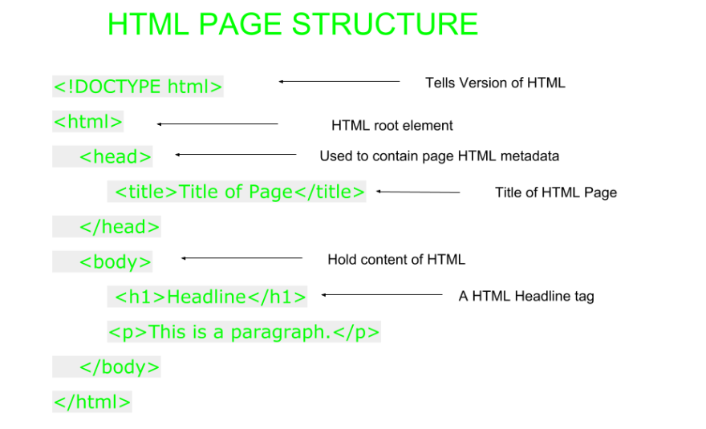**HTML page structure:** The Basic structure of HTML page is given below. It contain some elements like head, title, body, … etc. These elements are used to build the blocks of web pages.

**Features of HTML:**

* It is easy to learn and easy to use.
* It is platform independent.
* Images, video and audio can be added to a web page.
* Hypertext can be added to text.
* It is a markup language.

**INTRODUCTION OF CSS**

**Cascading Style Sheets** (**CSS**) is a style sheet language used for describing the presentation of a document written in a markup language.

**Cascading Style Sheets** (**CSS**) is a [style sheet language](https://en.wikipedia.org/wiki/Style_sheet_language) used for describing the [presentation](https://en.wikipedia.org/wiki/Presentation_semantics) of a document written in a [markup language](https://en.wikipedia.org/wiki/Markup_language).[[1]](https://en.wikipedia.org/wiki/Cascading_Style_Sheets#cite_note-1) Although most often used to set the visual style of [web pages](https://en.wikipedia.org/wiki/Web_page) and user interfaces written in [HTML](https://en.wikipedia.org/wiki/HTML) and [XHTML](https://en.wikipedia.org/wiki/XHTML), the language can be applied to any [XML](https://en.wikipedia.org/wiki/XML) document, including [plain XML](https://en.wikipedia.org/wiki/Plain_Old_XML), [SVG](https://en.wikipedia.org/wiki/Scalable_Vector_Graphics) and [XUL](https://en.wikipedia.org/wiki/XUL), and is applicable to rendering in [speech](https://en.wikipedia.org/wiki/Speech_synthesis), or on other media. Along with HTML and [JavaScript](https://en.wikipedia.org/wiki/JavaScript), CSS is a cornerstone technology used by most websites to create visually engaging webpages, user interfaces for [web applications](https://en.wikipedia.org/wiki/Web_applications), and user interfaces for many mobile applications.[[2]](https://en.wikipedia.org/wiki/Cascading_Style_Sheets#cite_note-2)

CSS is designed primarily to enable [the separation of document content from document presentation](https://en.wikipedia.org/wiki/Separation_of_presentation_and_content), including aspects such as the [layout](https://en.wikipedia.org/wiki/Page_layout), [colors](https://en.wikipedia.org/wiki/Color), and [fonts](https://en.wikipedia.org/wiki/Typeface).[[3]](https://en.wikipedia.org/wiki/Cascading_Style_Sheets#cite_note-3) This separation can improve content [accessibility](https://en.wikipedia.org/wiki/Accessibility), provide more flexibility and control in the specification of presentation characteristics, enable multiple HTML pages to share formatting by specifying the relevant CSS in a separate .css file, and reduce complexity and repetition in the structural content.

## **Advantages of CSS**

* **CSS saves time** − You can write CSS once and then reuse same sheet in multiple HTML pages. You can define a style for each HTML element and apply it to as many Web pages as you want.
* **Pages load faster** − If you are using CSS, you do not need to write HTML tag attributes every time. Just write one CSS rule of a tag and apply it to all the occurrences of that tag. So less code means faster download times.
* **Easy maintenance** − To make a global change, simply change the style, and all elements in all the web pages will be updated automatically.
* **Superior styles to HTML** − CSS has a much wider array of attributes than HTML, so you can give a far better look to your HTML page in comparison to HTML attributes.
* **Multiple Device Compatibility** − Style sheets allow content to be optimized for more than one type of device. By using the same HTML document, different versions of a website can be presented for handheld devices such as PDAs and cell phones or for printing.
* **Global web standards** − Now HTML attributes are being deprecated and it is being recommended to use CSS. So its a good idea to start using CSS in all the HTML pages to make them compatible to future browsers.

**INTRODUCTION TO PHP**

**What is PHP?**

PHP is an acronym for "PHP: Hypertext Preprocessor"

PHP is a widely-used, open source scripting language

PHP scripts are executed on the server

PHP is free to download and use

PHP is an amazing and popular language!

It is powerful enough to be at the core of the biggest blogging system on the web (WordPress)!

It is deep enough to run the largest social network (Facebook)!

It is also easy enough to be a beginner's first server side language!

**What is a PHP File?**

PHP files can contain text, HTML, CSS, JavaScript, and PHP code

PHP code are executed on the server, and the result is returned to the browser as plain HTML

PHP files have extension ".php"

**What Can PHP Do?**

PHP can generate dynamic page content

PHP can create, open, read, write, delete, and close files on the server

PHP can collect form data

PHP can send and receive cookies

PHP can add, delete, modify data in your database

PHP can be used to control user-access

PHP can encrypt data

With PHP you are not limited to output HTML. You can output images, PDF files, and even Flash movies. You can also output any text, such as XHTML and XML.

**Why PHP?**

PHP runs on various platforms (Windows, Linux, Unix, Mac OS X, etc.)

PHP is compatible with almost all servers used today (Apache, IIS, etc.)

PHP supports a wide range of databases

PHP is free. Download it from the official PHP resource: www.php.net

PHP is easy to learn and runs efficiently on the server side

**Introduction To Bootstrap:**

Bootstrap is a powerful front-end framework for faster and easier web development. It includes HTML and CSS based design templates for creating common user interface components like forms, buttons, navigations, dropdowns, alerts, modals, tabs, accordions, carousels, tooltips, and so on.

Bootstrap gives you ability to create flexible and responsive web layouts with much less efforts.

Bootstrap was originally created by a designer and a developer at Twitter in mid-2010. Before being an open-sourced framework, Bootstrap was known as Twitter Blueprint.

## **What You Can Do with Bootstrap**

There are lot more things you can do with Bootstrap.

* You can easily create responsive websites.
* You can quickly create multi-column layout with pre-defined classes.
* You can quickly create different types of form layouts.
* You can quickly create different variation of navigation bar.
* You can easily create components like accordions, modals, etc. without writing any JS code.
* You can easily create dynamic tabs to manage large amount of content.
* You can easily create tooltips and popovers to show hint text.
* You can easily create carousel or image slider to showcase your content.
* You can quickly create different types of alert boxes.

## **Advantages of Using Bootstrap**

If you have had some experience with any front-end framework, you might be wondering what makes Bootstrap so special. Here are some advantages why one should opt for Bootstrap framework:

* **Save lots of time** — You can save lots of time and efforts using the Bootstrap predefined design templates and classes and concentrate on other development work.
* **Responsive features** — Using Bootstrap you can easily create responsive websites that appear more appropriately on different devices and screen resolutions without any change in markup.
* **Consistent design** — All Bootstrap components share the same design templates and styles through a central library, so the design and layout of your web pages will be consistent.
* **Easy to use** — Bootstrap is very easy to use. Anybody with the basic working knowledge of HTML, CSS and JavaScript can start development with Bootstrap.
* **Compatible with browsers** — Bootstrap is created with modern web browsers in mind and it is compatible with all modern browsers such as Chrome, Firefox, Safari, Internet Explorer, etc.
* **Open Source** — And the best part is, it is completely free to download and use.

**Data Flow Diagram**

A data flow diagram is graphical tool used to describe and analyze movement of data through a system. These are the central tool and the basis from which the other components are developed. The transformation of data from input to output, through processed, may be described logically and independently of physical components associated with the system. These are known as the logical data flow diagrams. The physical data flow diagrams show the actual implements and movement of data between people, departments and workstations. A full description of a system actually consists of a set of data flow diagrams. Using two familiar notations Yourdon, Game and Samson notation develops the data flow diagrams. Each component in a DFD is labeled with a descriptive name. Process is further identified with a number that will be used for identification purpose. The development of DFD’S is done in several levels. Each process in lower level diagrams can be broken down into a more detailed DFD in the next level. The lop-level diagram is often called context diagram. It consists a single process bit, which plays vital role in studying the current system. The process in the context level diagram is exploded into other process at the first level DFD.

The idea behind the explosion of a process into more process is that understanding at one level of detail is exploded into greater detail at the next level. This is done until further explosion is necessary and an adequate amount of detail is described for analyst to understand the process.

Larry Constantine first developed the DFD as a way of expressing system requirements in a graphical from, this lead to the modular design.

A DFD is also known as a “bubble Chart” has the purpose of clarifying system requirements and identifying major transformations that will become programs in system design. So it is the starting point of the design to the lowest level of detail. A DFD consists of a series of bubbles joined by data flows in the system.

**DFD SYMBOLS:**

In the DFD, there are four symbols

1. A square defines a source(originator) or destination of system data
2. An arrow identifies data flow. It is the pipeline through which the information flows
3. A circle or a bubble represents a process that transforms incoming data flow into outgoing data flows.
4. An open rectangle is a data store, data at rest or a temporary repository of data

Process that transforms data flow.

Source or Destination of data

Data flow

Data Store

**DATA FLOW**

1) A Data Flow has only one direction of flow between symbols. It may flow in both directions between a process and a data store to show a read before an update. The later is usually indicated however by two separate arrows since these happen at different type.

1. A join in DFD means that exactly the same data comes from any of two or more different processes data store or sink to a common location.
2. A data flow cannot go directly back to the same process it leads. There must be at least one other process that handles the data flow produce some other data flow returns the original data into the beginning process.

**Chapter – 4**

**Data Flow Diagram**

1. A Data flow to a data store means update (delete or change).
2. A data Flow from a data store means retrieve or use.

A data flow has a noun phrase label more than one data flow noun phrase can appear on a single arrow as long as all of the flows on the same arrow move together as one package.

**DATA FLOW DIAGRAM:-**

1. **Admin:**

ADMIN LOGIN

AUTHENTICATE ADMIN

LOG IN

DASHBOARD

POST APPROVAL

WRITERS

DATABASE

**NO**

**YES**

1. **Users:**

HOME

MEMBER LOG-IN

LOG_OUT

REGISTER

LOG_IN

DASH BOARD

UPDATE PROFILE

UPDATE POST

CREATE POST

**hh**

**LOG- DATABASE**

**DATABASE**

1. **Visitors:**

**TEAM**

**BLOG**

**MEMBER LOGIN**

**CONTACT**

**VISITORS**

**HOME**

**ABOUT**

**SCREENSHOT**

1. **Home Page:**

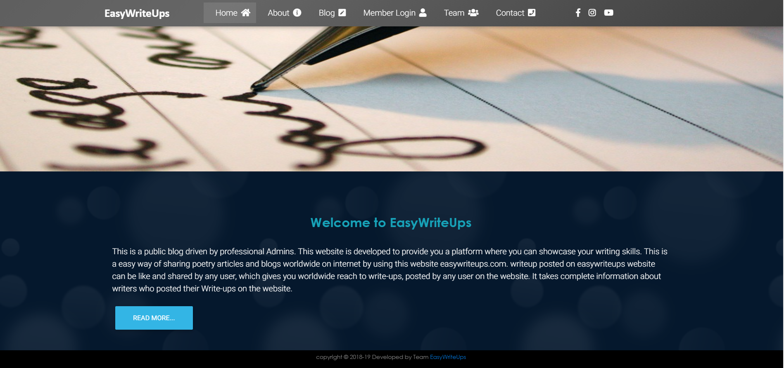

1. **About Paage:**

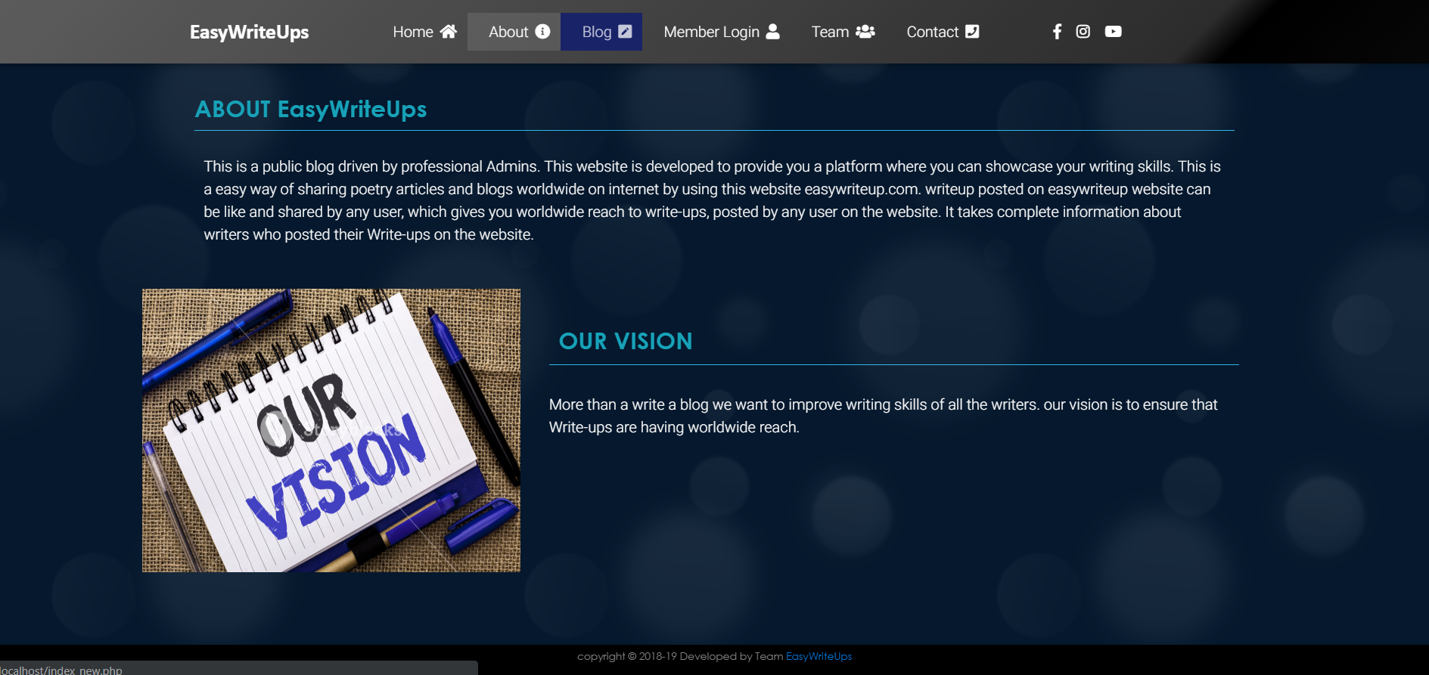

1. **Blog Page:**

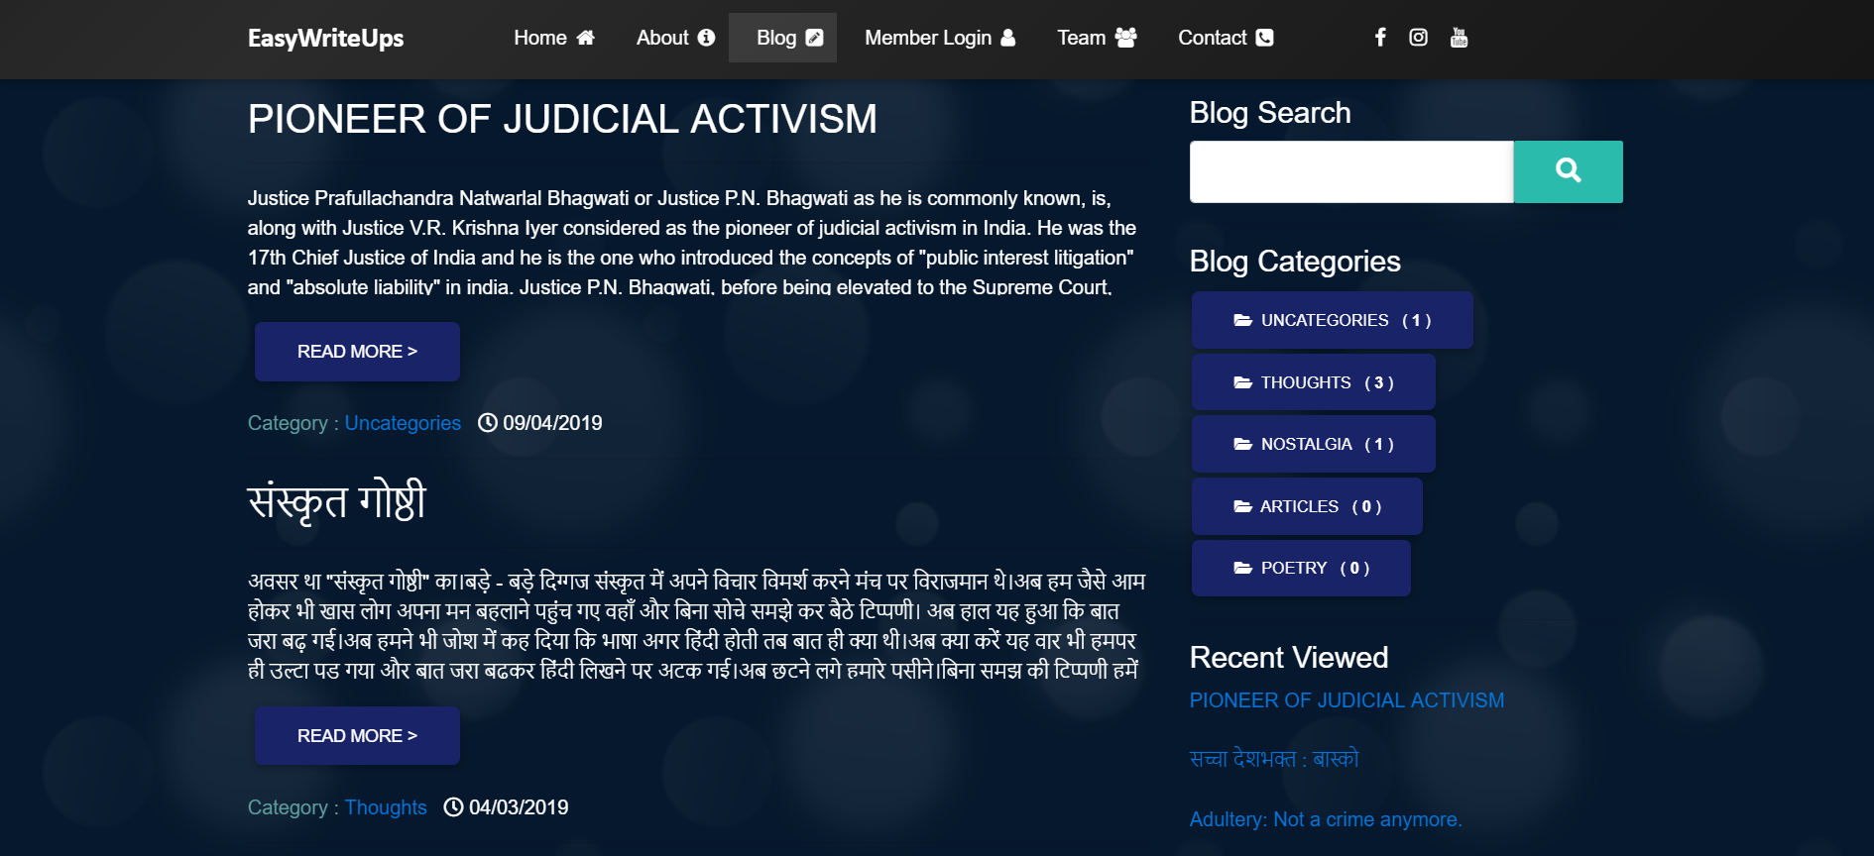

**By clicking Read More of any article you go to the below page:**

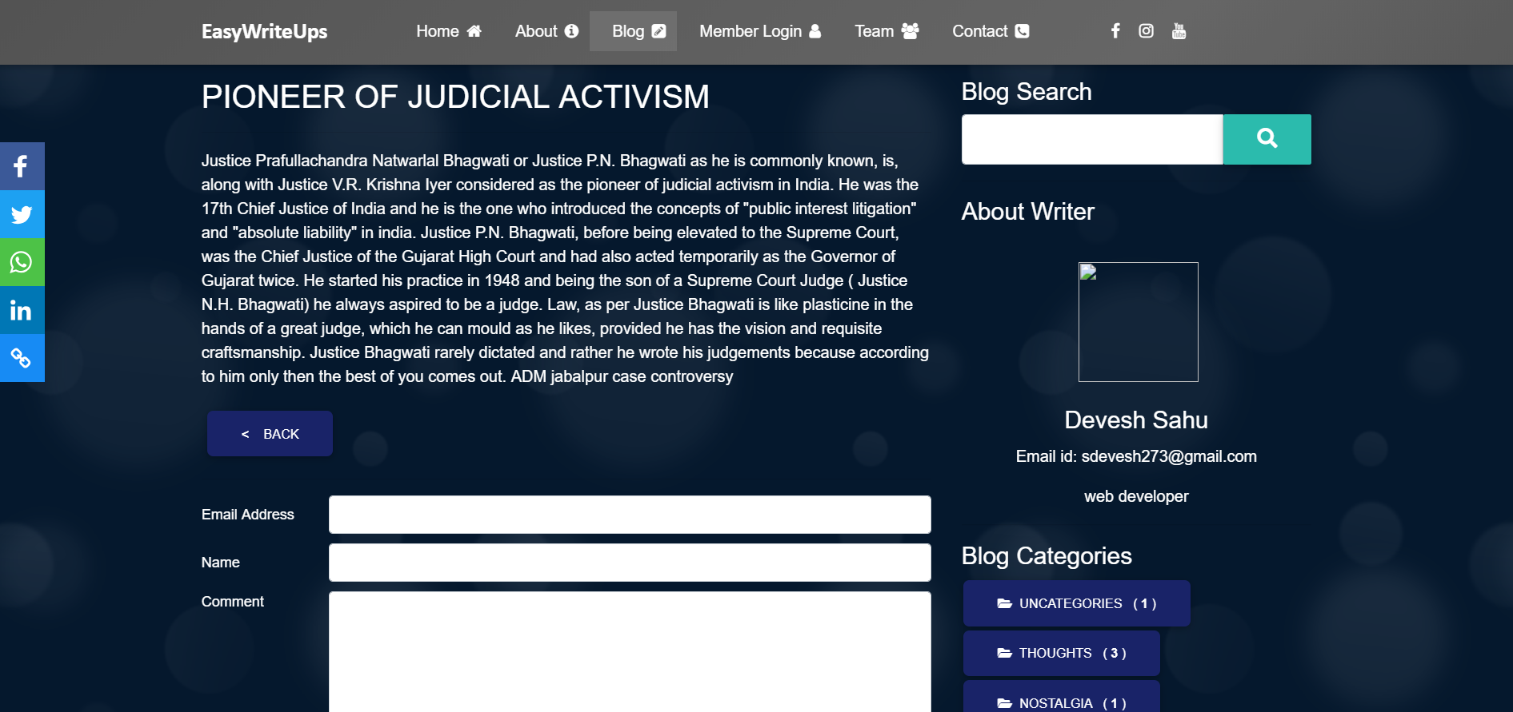



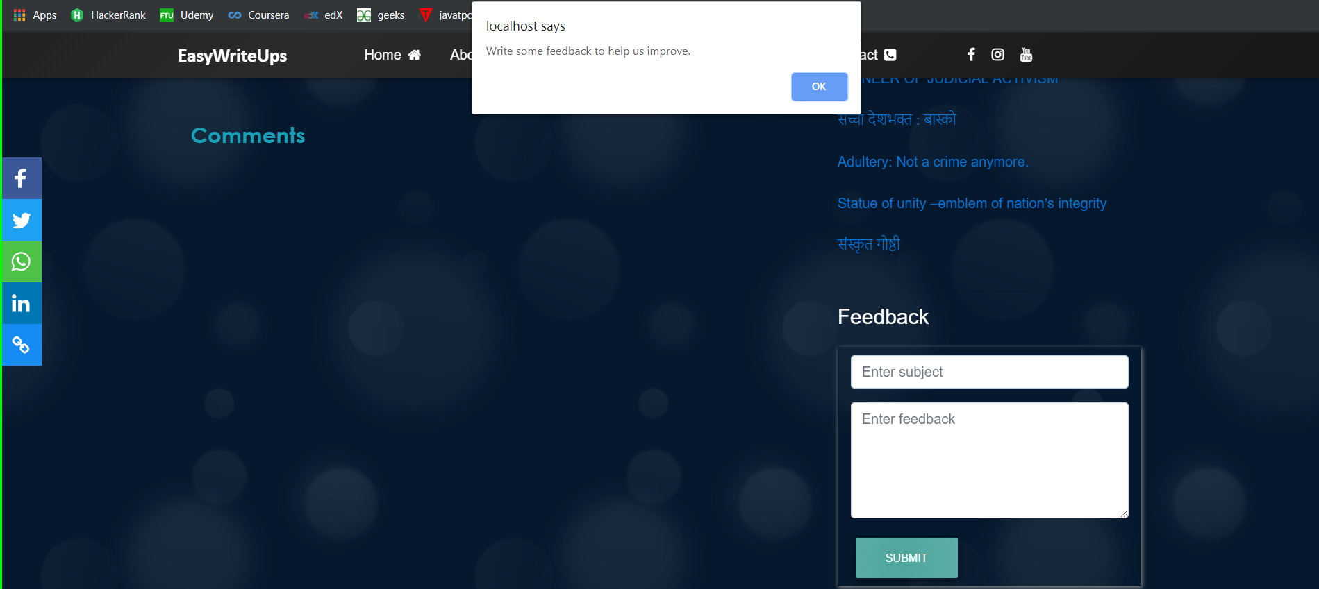



1. **Member Login-Register Page:**

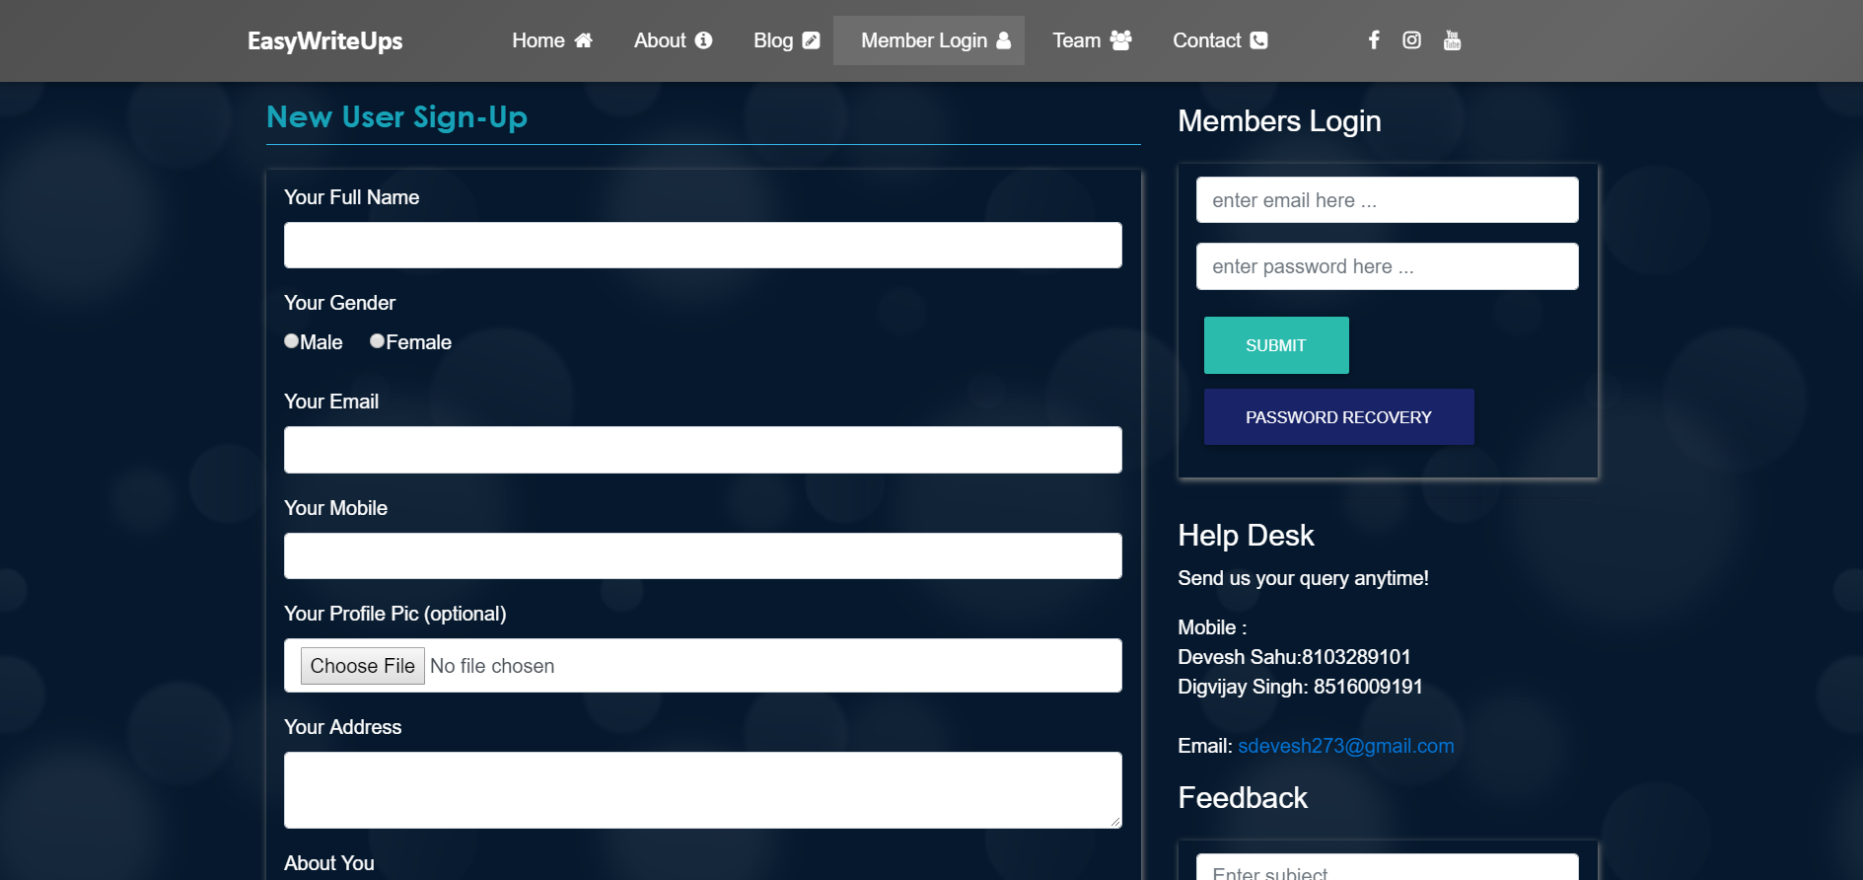

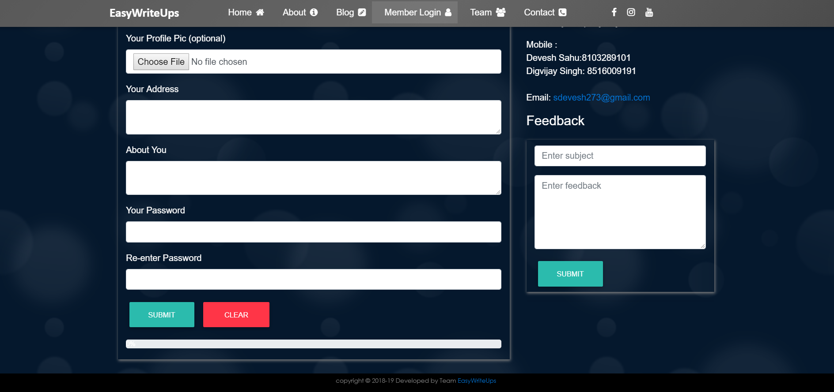

**If you are existing user go to login section and logged in.**

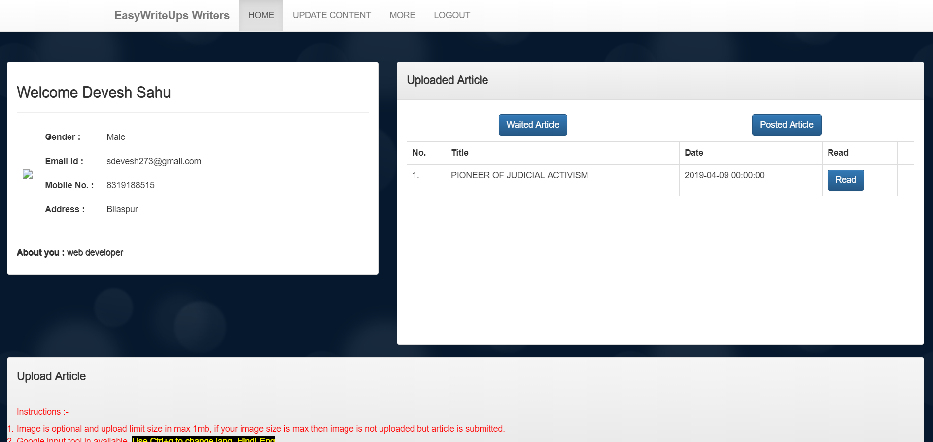

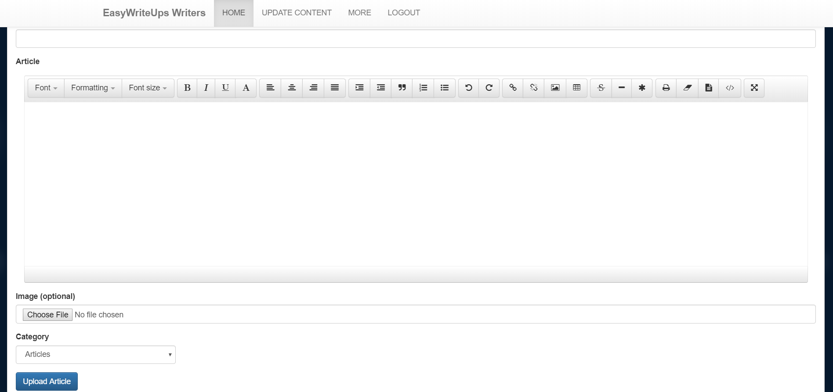

1. **Update Article Page:**

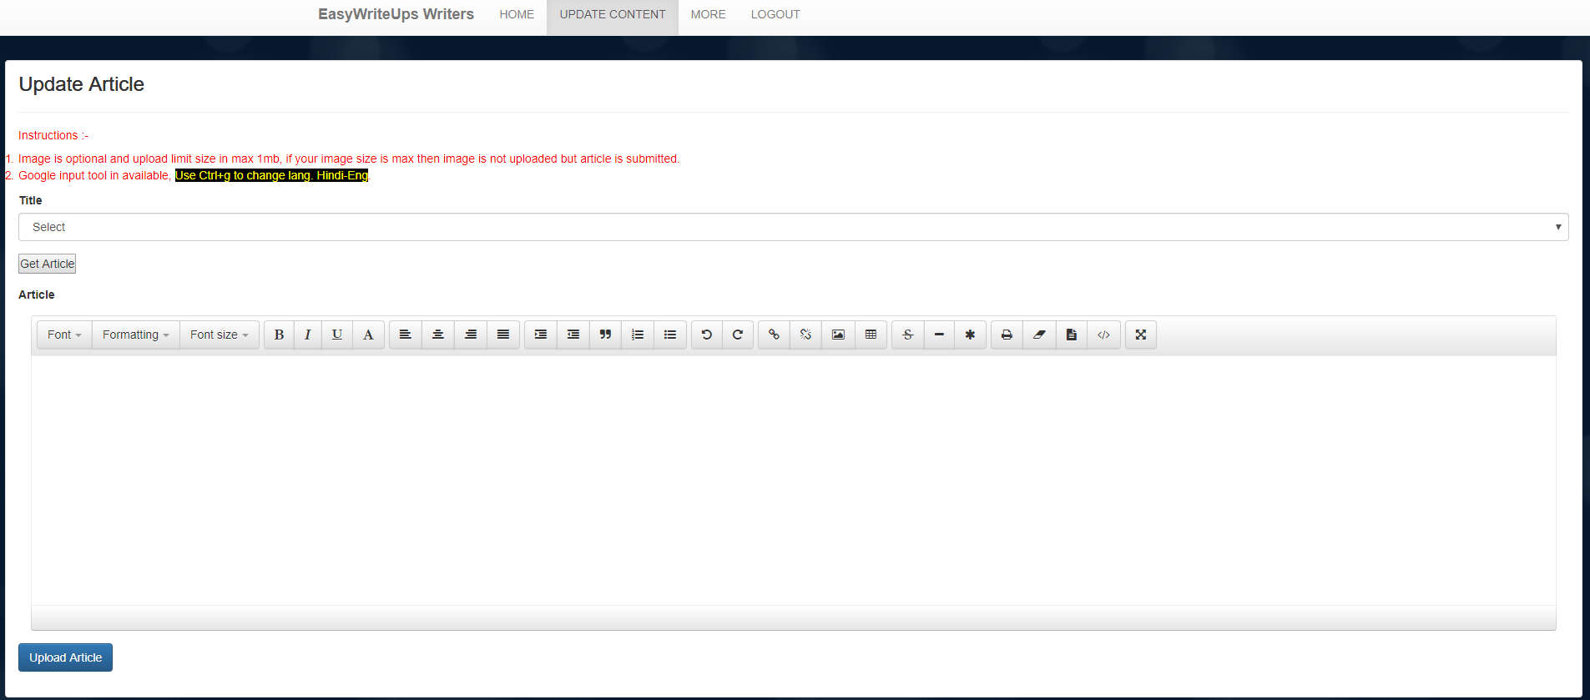

1. **More Page:**

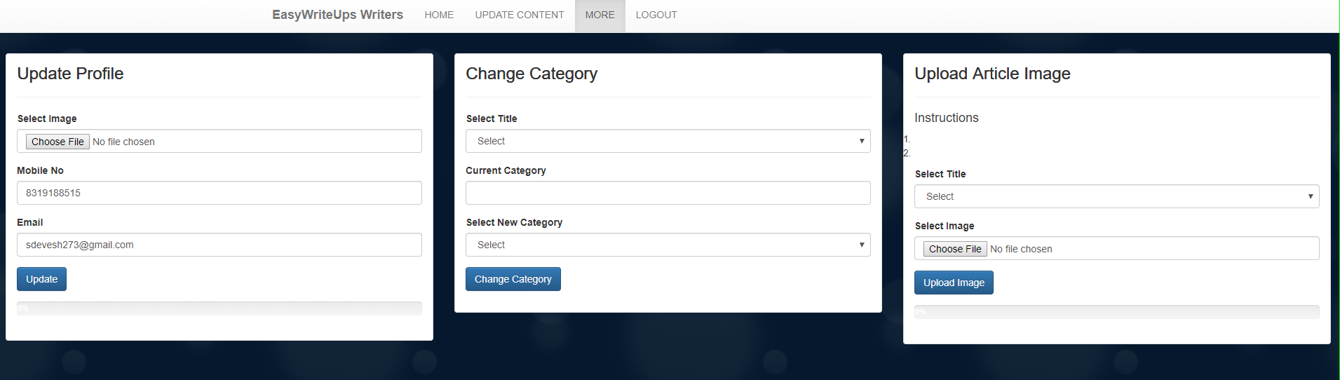

**After clicking logout button we jump to member login page.**

1. 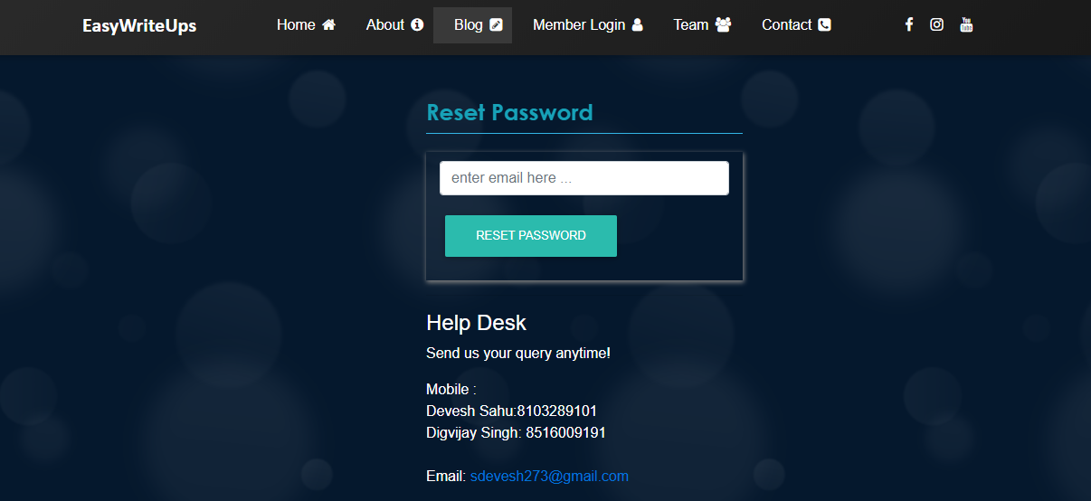**Recover Password:**
2. **Team Page:**

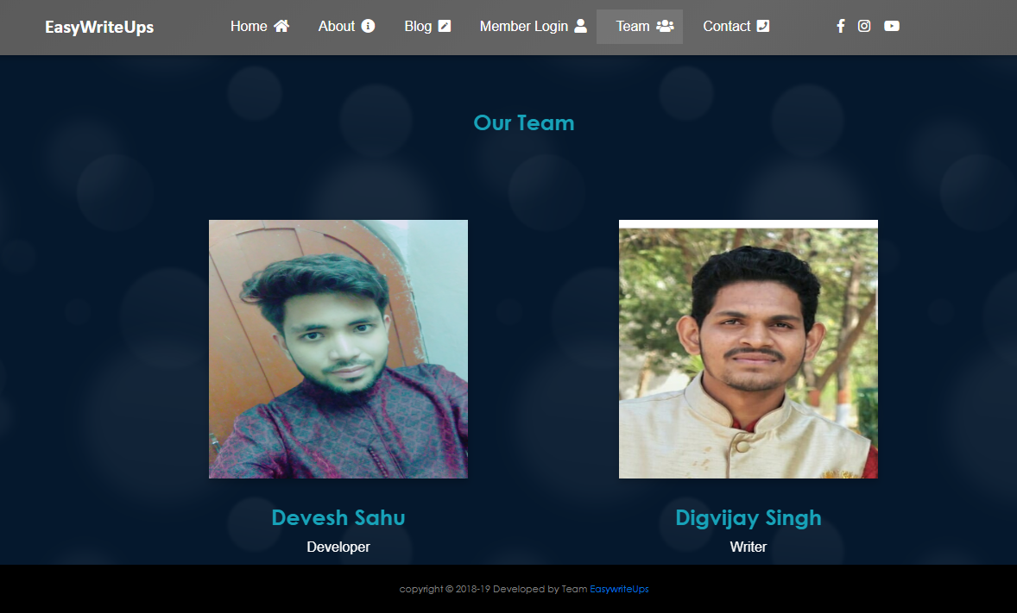

1. **Contact Page:**

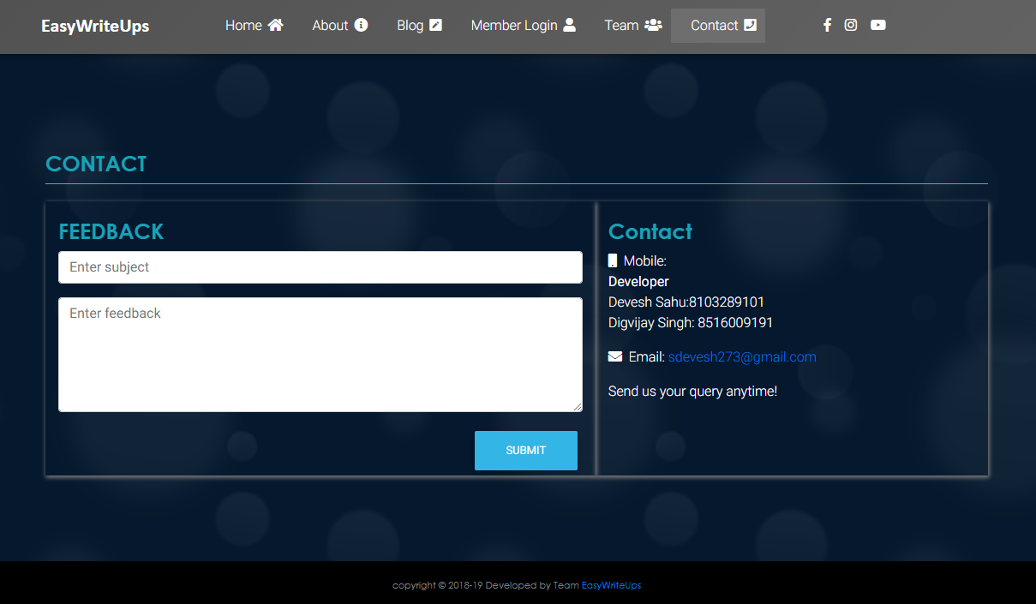

1. **Admin Page:**

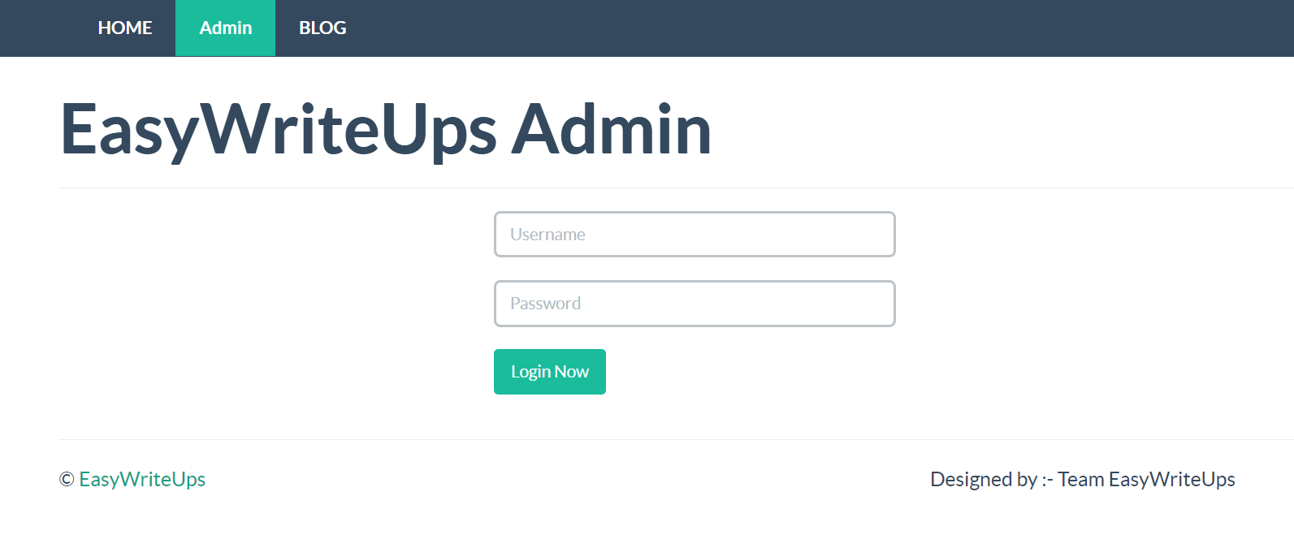

1. **Admin Panel:**

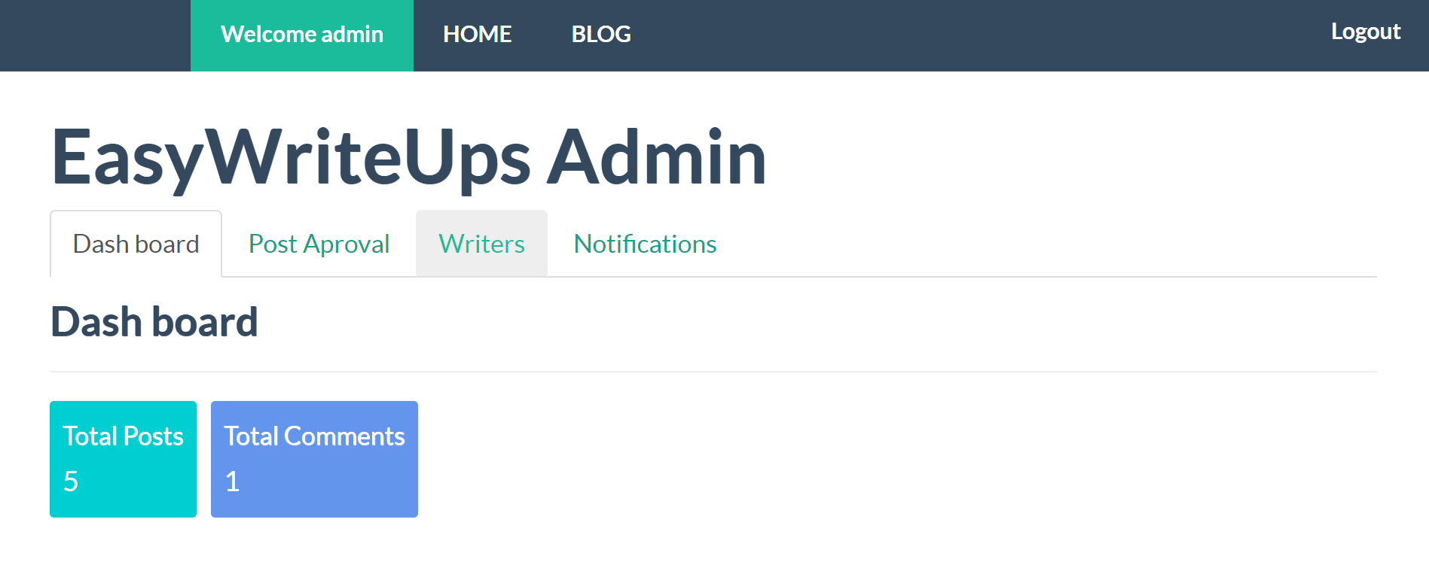

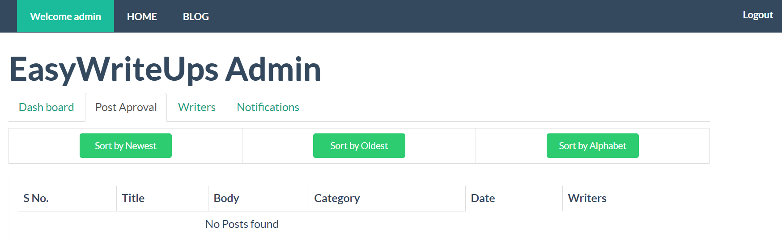

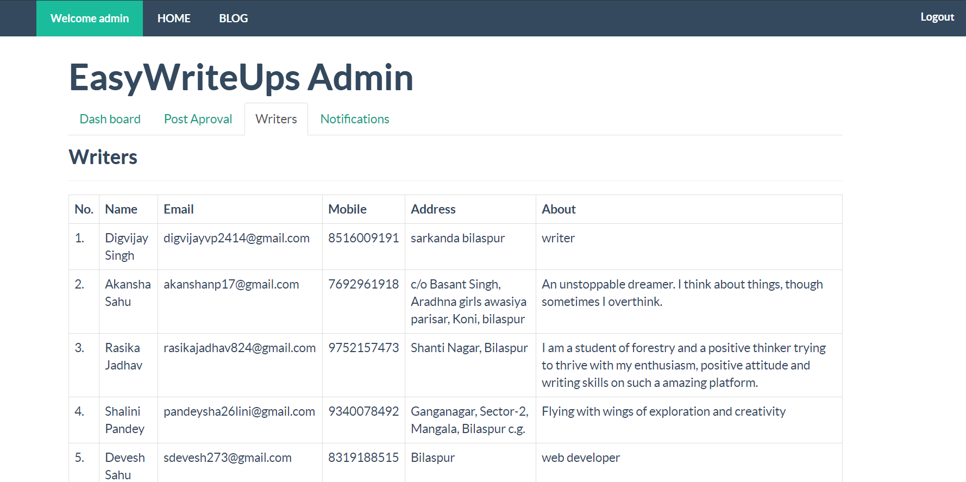

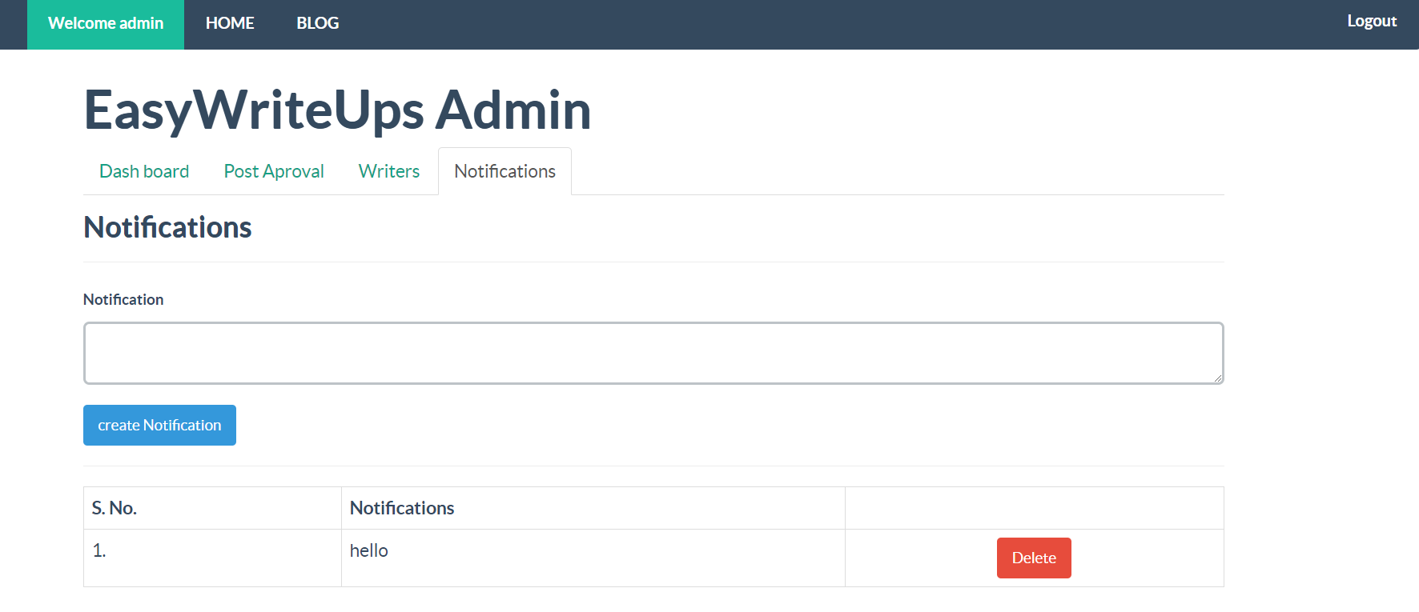

**After clicking logout button it redirects to home page.**

**Database:**

**Writers Table:**

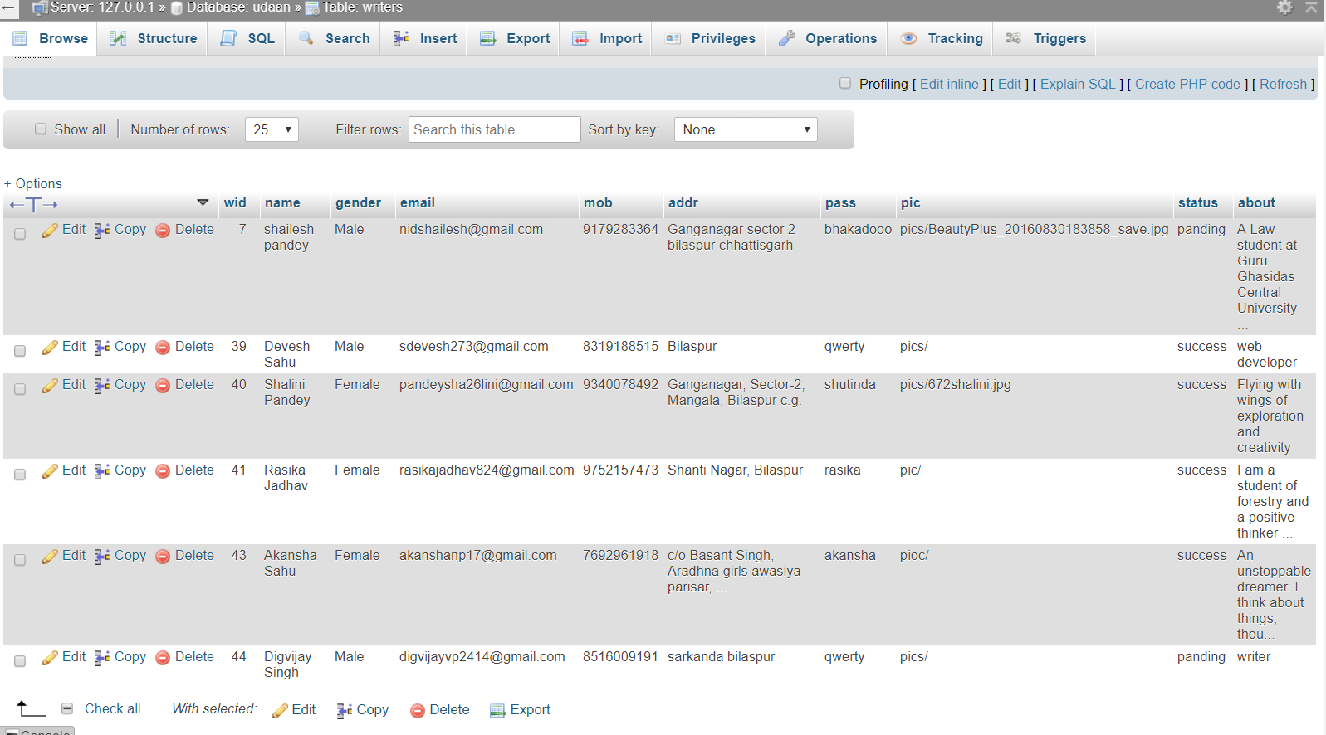

**Posts Table:**

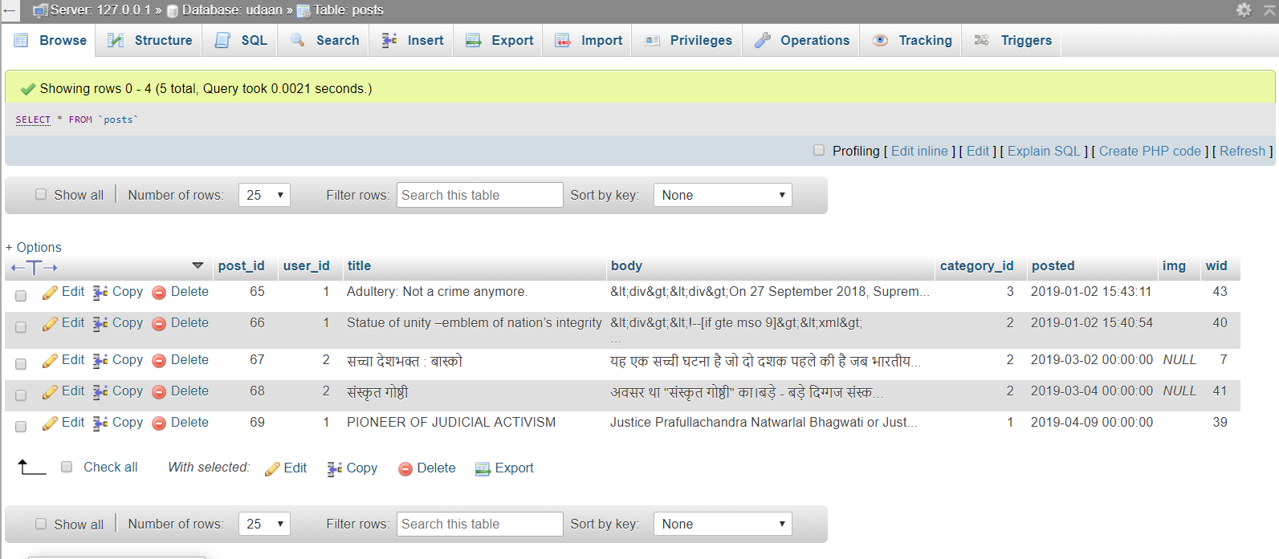

**Post Temp table:**

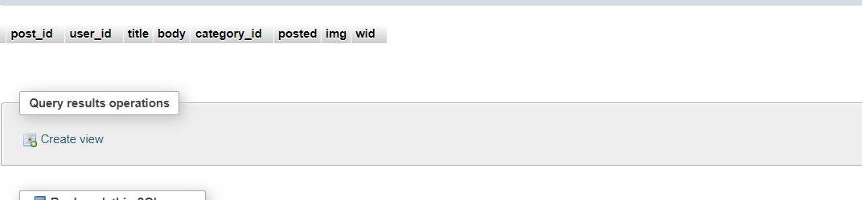

**Comment table:**

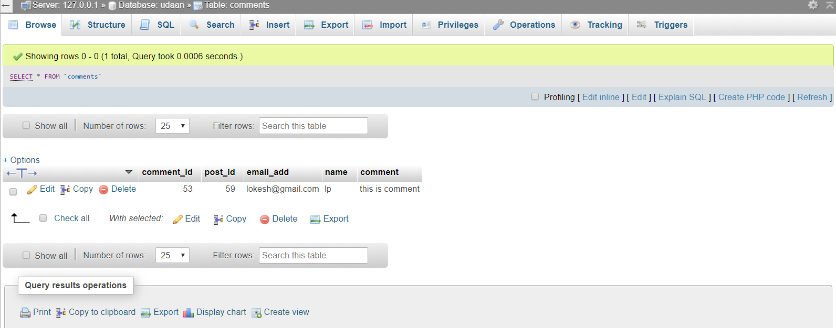

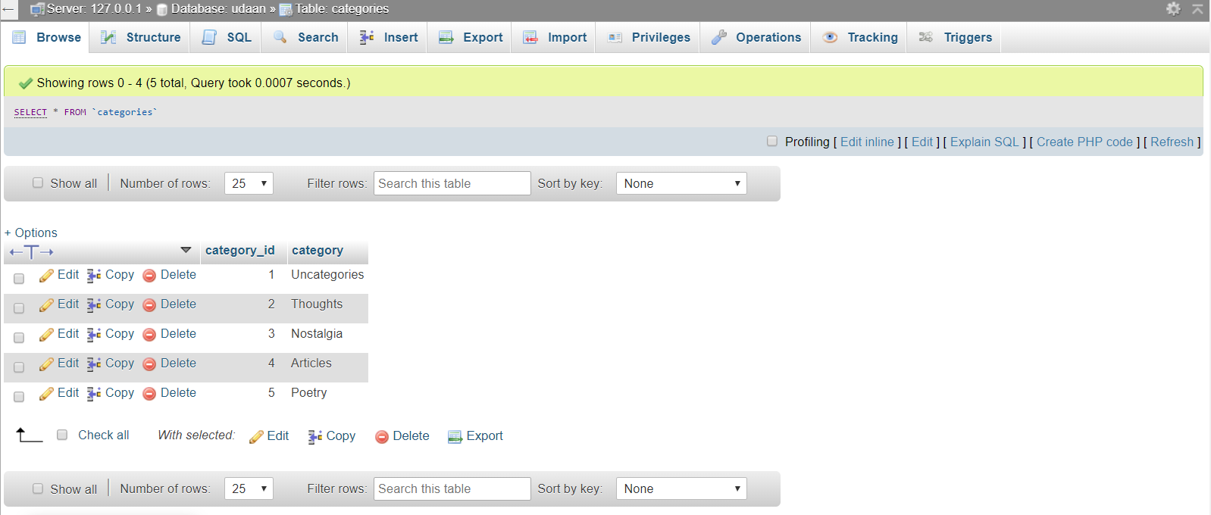**Categories Table:**

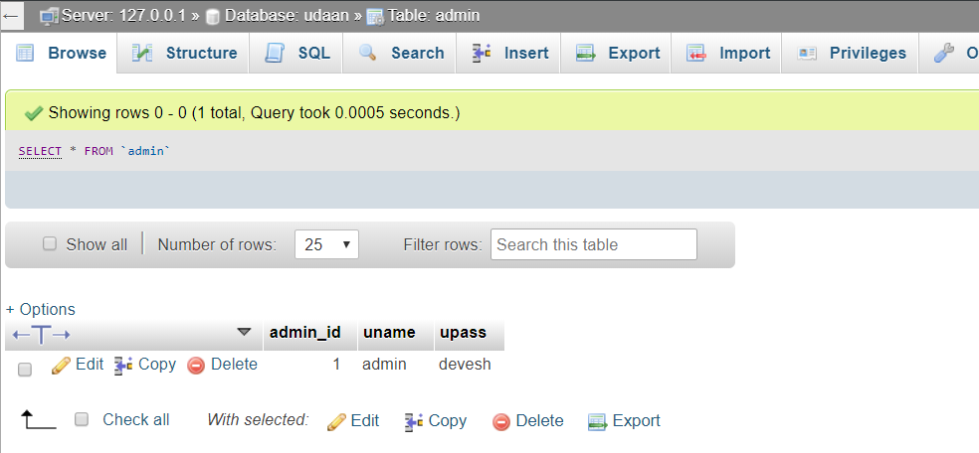**Admin Table:**

**Recent Post:**

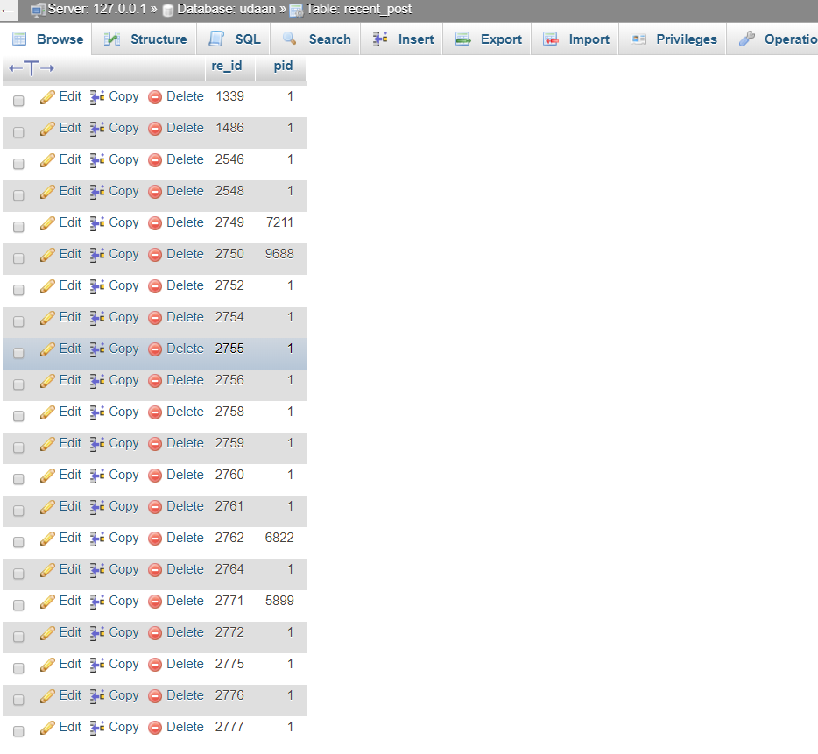

**Notify table:**

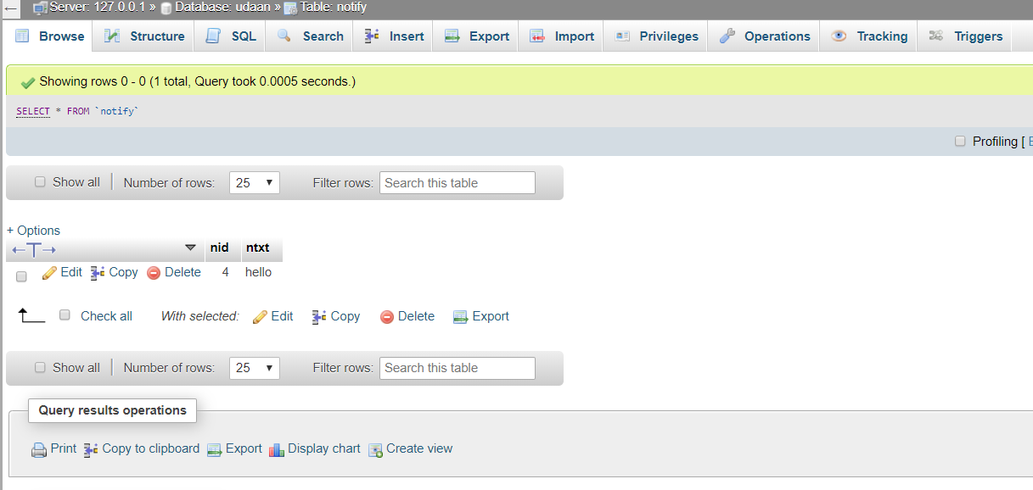

**CONCLUSION:**

This project developed, incorporated all the activities involved in the browsing Centre.

**EASYWRITEUPS** provides all necessary information to the user with the use **EASYWRITEUPS**; the user can simply sit in front of the system and monitor all the activities without any physical movement of the file. Management can service the user’s request best in time.

The **EASYWRITEUPS** provides quickly and valuable information. These modules have been integrated for effective use of the management for future forecasting and for the current need.

**FUTURE ASPECTS OF PROJECT:**

* Reduces the Usage of Paper and Pages.
* Increases the habit to use Websites to Store articles.
* To showcase hidden writers of Small towns.
* To improve writing skills of writers.
* Enhance the security methods.
* Normalization of database table to improve database structure & easily retrieval of user data.
* To develop auto approval algorithm.

**BIBLIOGRAPHY**

[www.webdeveloper.com](http://www.webdeveloper.com)

[www.w3school.com](http://www.w3school.com/)

[www.youtube.com](http://www.youtube.com)

<https://getbootstrap.com>

<https://fontawesome.com/icons>

<https://www.php.net/manual/en/intro-whatis.php>

<https://www.geeksforgeeks.org>

<https://www.tutorialspoint.com>

<https://codepen.io/Mr_Smith/pen/YPLoKW>